**The Designing Steps Used For The OPAMP**:

**Design Steps:**

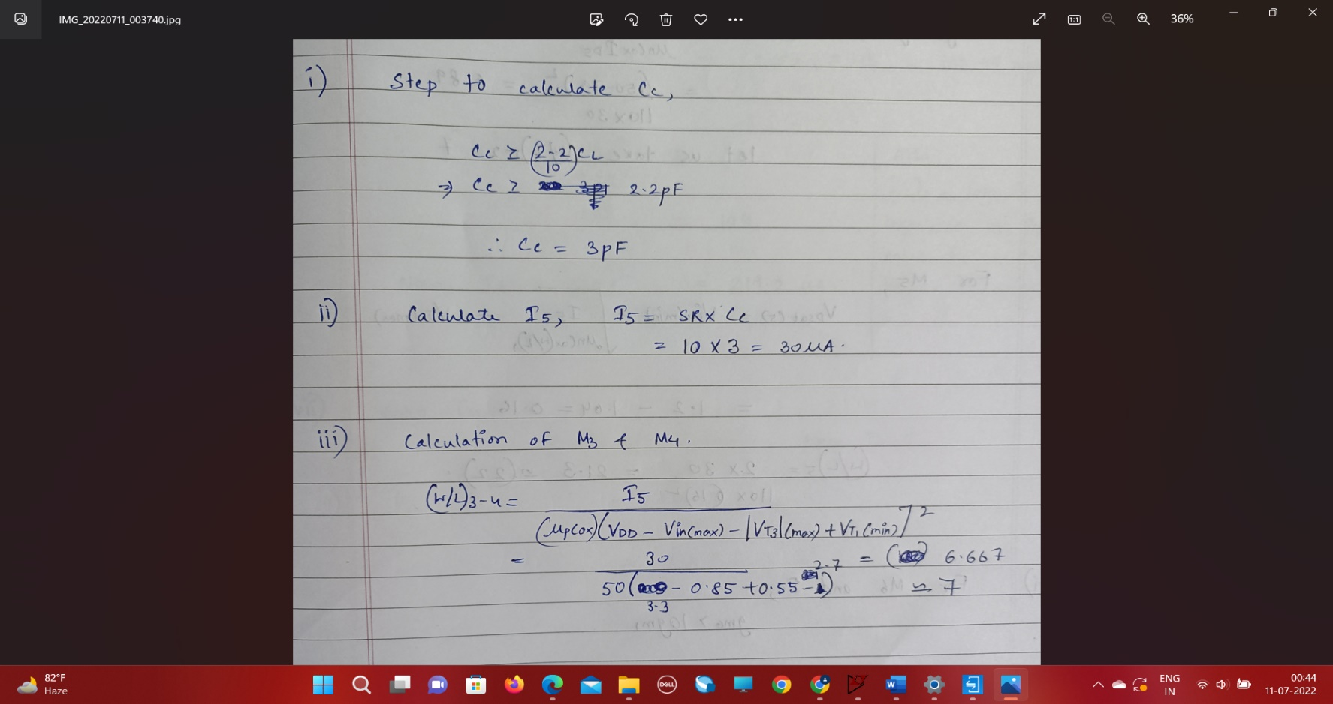

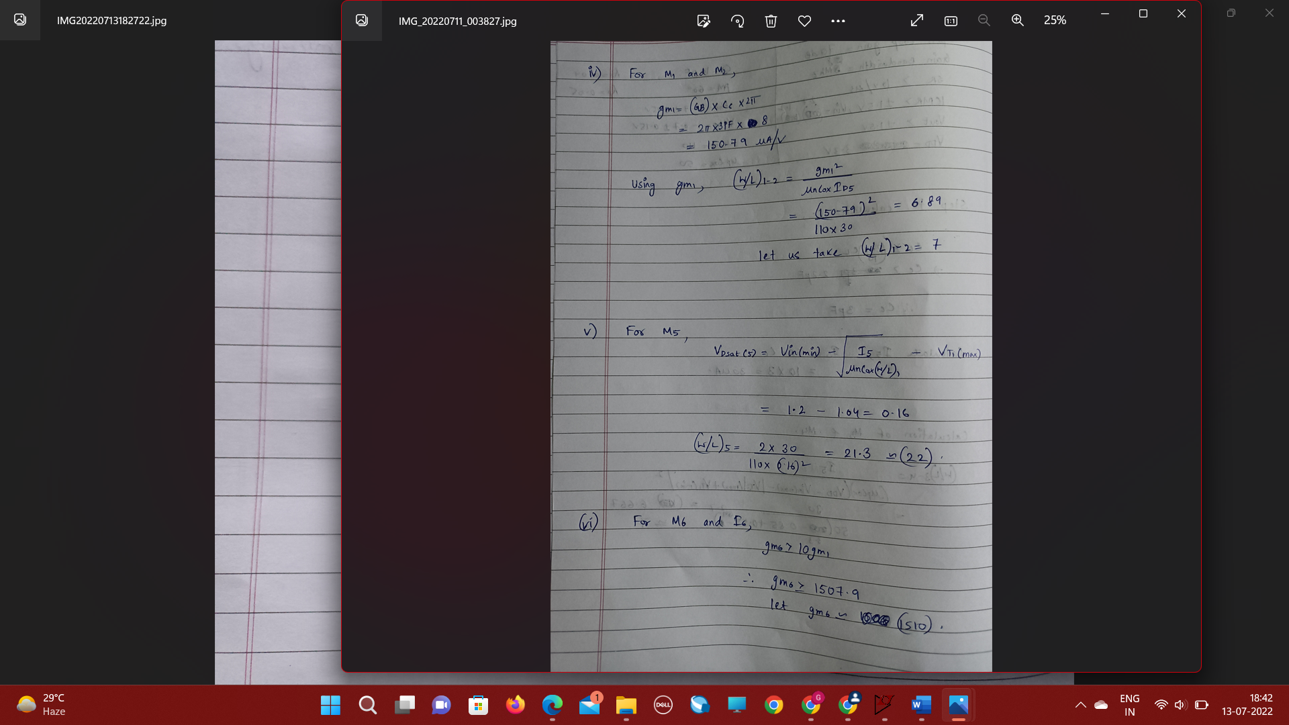

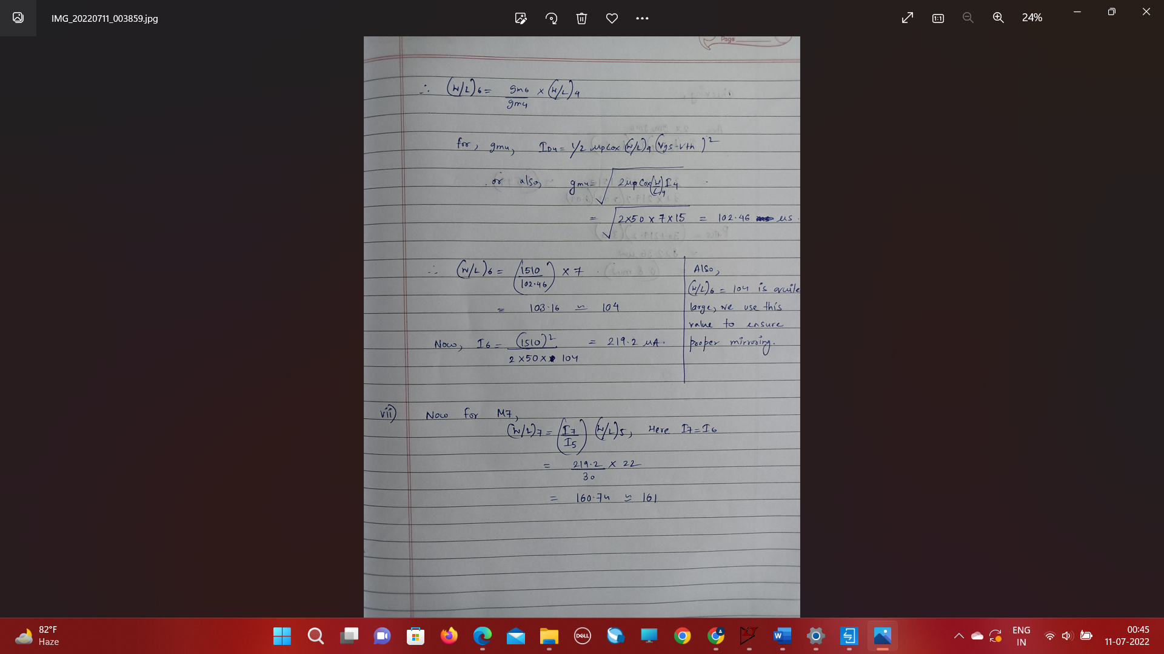

**Checking the gain as well as power dissipation from the calculated values**

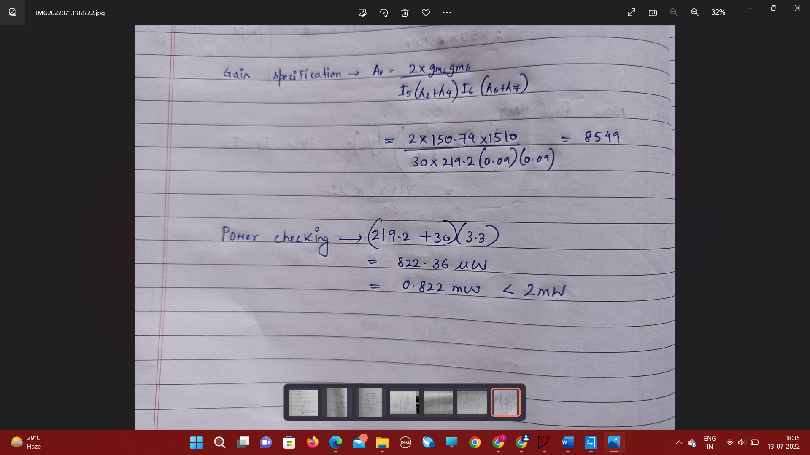

**Some of the observations:**

1. Our design produced an open loop gain of about **82db** with a considerable phase margin of **69 degree** as originally opposed to **70db** and **60 degree** margin.
2. Overall power dissipation is about **0.8mW** which is quite low as compared to the higher limit that we set of about **2mW**.

|  |  |  |
| --- | --- | --- |
| Parameter | Calculated Value | Obtained Value |
| gm1 | 150.8uS | 152uS |
| gm6 | 1510uS | 1600uS |
| Id6 | 219.2uA | 219.04uA |

**Some tradeoffs:**

On changing the value of **compensating capacitor** ,for different values :

|  |  |
| --- | --- |
| Cc (pF) | PM (deg) |
| 2.2 | 64 |
| 2.6 | 67 |
| 3 | 69 |
| 3.5 | 71 |

We observe that the phase margin increases.

**Effect of changing (W/L)6,**

|  |  |  |  |
| --- | --- | --- | --- |
| (W/L)6 | Id6(uA) | Gain(dB) | PM(deg) |
| 110 | 225 | 81 | 69 |
| 120 | 234 | 81 | 70 |
| 125 | 239 | 81 | 71 |

As observed ,on increasing W/L for M6 we were able to increase phase margin even though experimentally no visible change was observed in the gain value. Also Current through M6 increased which would ultimately increase the overall power dissipation in the circuit.